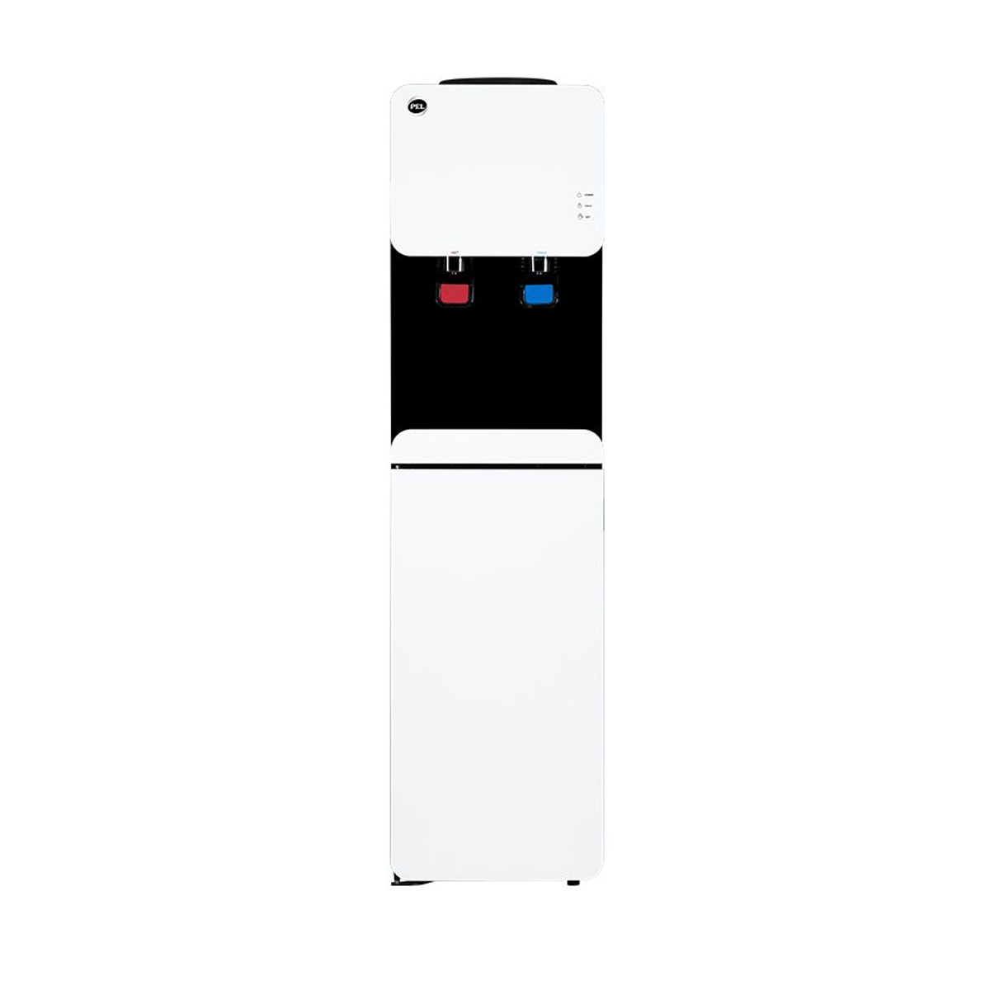

***Pel 9160LF automatic loaded Water dispenser***

* **Color:**white/Black
* **Available:**in stock
* **Dimension:**1641*595*600
* **Size:**19
* **Old Price:**~~Rs 44,000.00~~
* **New Price:**Rs 40,500.00